PAPERSTUDIO’s CZAR

Complete Specification
Add a chat interface to PAPERSTUDIO CALLED “CZAR.” What CZAR is: CZAR is not a chatbot attached to a writing tool. CZAR is a different product interface for doing other work that are not dissertations. CZAR’s entire experience happens inside a single conversational interface. There is no separate editor, no dashboard of buttons, no multi-step wizard. The user talks to CZAR, and CZAR does everything.
See sample chat interface. Should open to full screen on PC and mobile and should be able to be closed, etc. Should also have history, settings, user should be able to navigate to STUDIO from there… think all it needs and add. Should be equal to chatgpt/claude interfaces (at least) but better than.
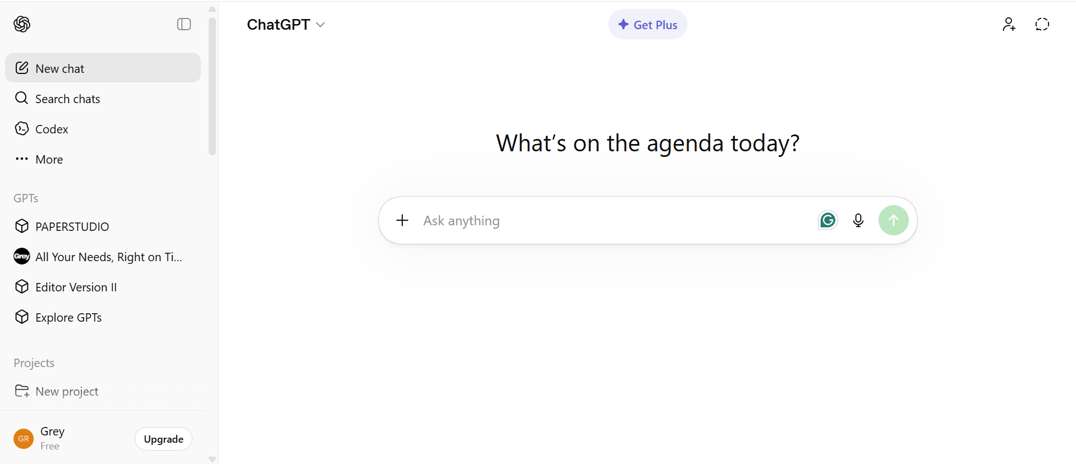
The user journey:
- User registers and purchases a plan (Hello / Regular / Professional / Custom via Paystack).
- Upon payment confirmation, CZAR becomes accessible — the chat interface is their workspace.
- User tells CZAR what they need in natural language or uploads it as a file: "I need a 3000-word postgraduate essay on Tesla's market entry strategy, Harvard referencing, critical analytical tone."
- CZAR autonomously decides:
- Whether to run the full academic pipeline (brief parsing → execution plan → section generation → quality pass → humanisation → export) or a lighter workflow (e.g., casual blog post, simple summary — no citations, no Five-Layer Justification).
- Which AI model to use at each stage — CZAR picks the optimal model based on task complexity, not user choice. For heavy academic reasoning: `google/gemini-2.5-pro` or `openai/gpt-5`. For fast drafts or simple tasks: `google/gemini-2.5-flash` or `openai/gpt-5-nano`. For image generation: `google/gemini-3.1-flash-image-preview`. CZAR can also switch between instant and thinking/reasoning modes (using the `reasoning.effort` parameter) depending on the task's difficulty.
- Which internal templates, rules, and quality standards to apply — the CZAR Brain prompt library, Five-Layer Justification, banned phrase list, UK English enforcement, A+ criteria checklist. These are applied to academic work; lighter standards for non-academic work.
- CZAR executes the work — streaming the output directly into the chat. The user sees it being written in real time.
- When complete, the user can:
- Download immediately (.docx, .pdf, .txt… all file formats) — one tap.
- Copy to clipboard — one tap.
- Ask CZAR to revise — "Make the introduction more critical" and CZAR re-runs just that section.
- Ask CZAR to generate images — academic figures, charts, diagrams rendered inline in the chat.
- Ask CZAR to find real sources — Semantic Scholar integration, no hallucinated references.
- Tier determines the writing model, not the orchestration model:
- All tiers get CZAR's full intelligence for deciding what to do (orchestration always uses a capable model).
- The tier determines which model writes the final content:
- Hello → `google/gemini-2.5-flash` (fast, good quality)
- Regular → `google/gemini-2.5-pro` (strong reasoning, deep analysis)
- Professional → `openai/gpt-5` or `openai/gpt-5.2` (top-tier output)
- Custom → Best available model, with thinking/reasoning enabled.
- All AI costs are absorbed by the platform — the user never sees or pays for API usage directly.
- CZAR's full capabilities (all executable from chat):
- Create, write, revise, critique, humanise, and export academic documents
- Generate images and data visualisations inline
- Search the web and find verified academic sources
- Manage assessments (create, rename, delete)
- Handle subscriptions and payments (upgrade, downgrade via Paystack)
- Navigate the user to any page
- Read back content, predict grades, format citations
- Process uploaded files (PDF, DOCX, images, spreadsheets)
- Apply templates from an internal library for structure and quality
- CZAR's internal library (to be uploaded):
- Structural templates.
- Creation/Guiding Prompts
- CZAR draws from these automatically based on the work type.
- What makes this different from ChatGPT or Claude:
- CZAR has full executive control — it doesn't just generate text, it manages the entire application state (database, files, navigation, payments).
- CZAR has domain expertise baked in — the CZAR Brain prompt system, quality standards, and banned phrases make it a specialist, not a generalist.
- CZAR decides its own approach — model selection, pipeline depth, quality standards are all autonomous decisions, not user configuration.
- CZAR chat should open a full screen chat interface on both PC and mobile to make it easy to use.
- Immediately user states what they want, CZARs next action should be to begin writing or doing exactly what’s required by user.
- If CZAR needs clarification, CZAR should bring up a form with list for user to tick to confirm or fill in what they need. Once done, CZAR should execute.
- Writing UI should be black and white(charcoal black/amoled black or so and white).

